**VISVESVARAYA TECHNOLOGICAL UNIVERSITY**

**“Jnana Sangama”, Belgaum – 590018**

**MIHIRA TECHNOLOGY**

**Golmuri, Jamshedpur - 831003**

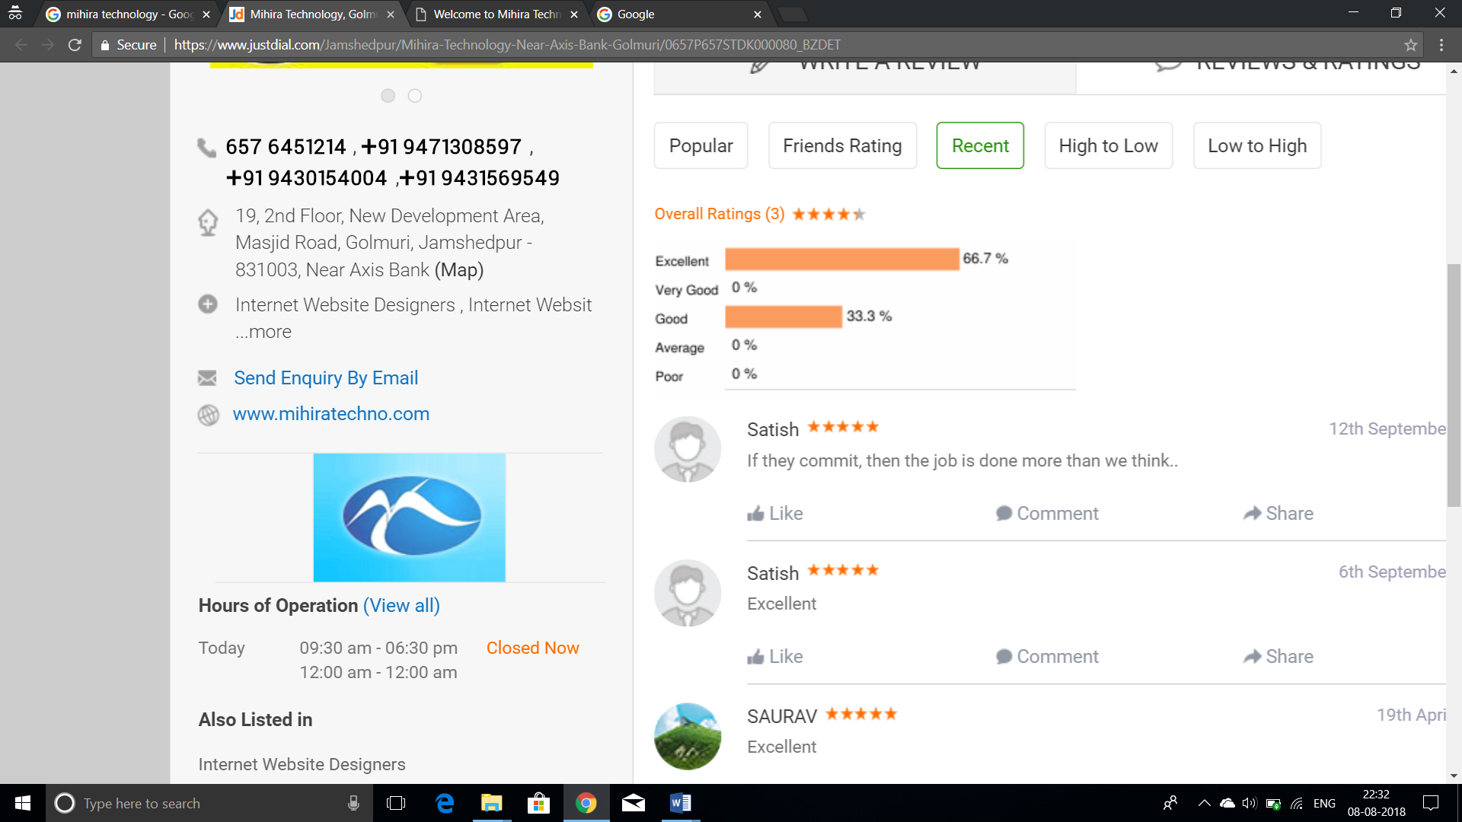

**INTERNSHIP REPORT**

on

# customer Service status

*Submitted in partial fulfillment of the requirements for B.E*

Bachelor of Engineering

in

# Electronics and Communication Engineering

by

Nemaly Praveen Kumar - (1BG15EC066)

Under the guidance of

Ms. Marzina Khatoon



**B. N. M. Institute of Technology**

12th Main, 27th Cross, Banashankari II Stage, Bengaluru - 560 070

**Department of Electronics and Communication Engineering**

2017 - 2018